Cathy Humphreys
Fractions Video

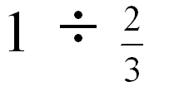

CH: “Without doing a rule that you know, like, see if you can make sense of why, what one divided by two-thirds is.”

Mathematically
- What is the claim being discussed?
- What are the arguments that students are making? (Try to mark each argument on your transcript.)
- What counterarguments? (which are also arguments)

Pedagogically
- What is the teacher doing to support (or hinder) students’ engagement with argumentation?
  - Watch for “talk moves” or other pedagogical moves
- What are the students doing that support (or hinder) argumentation?

Video from Connecting Mathematical Ideas: Middle School Video cases to support Teaching and Learning – Boaler & Humphreys

