THE HEXAGON TASK

Each figure in the pattern below is made of hexagons that measure 1 cm on each side.

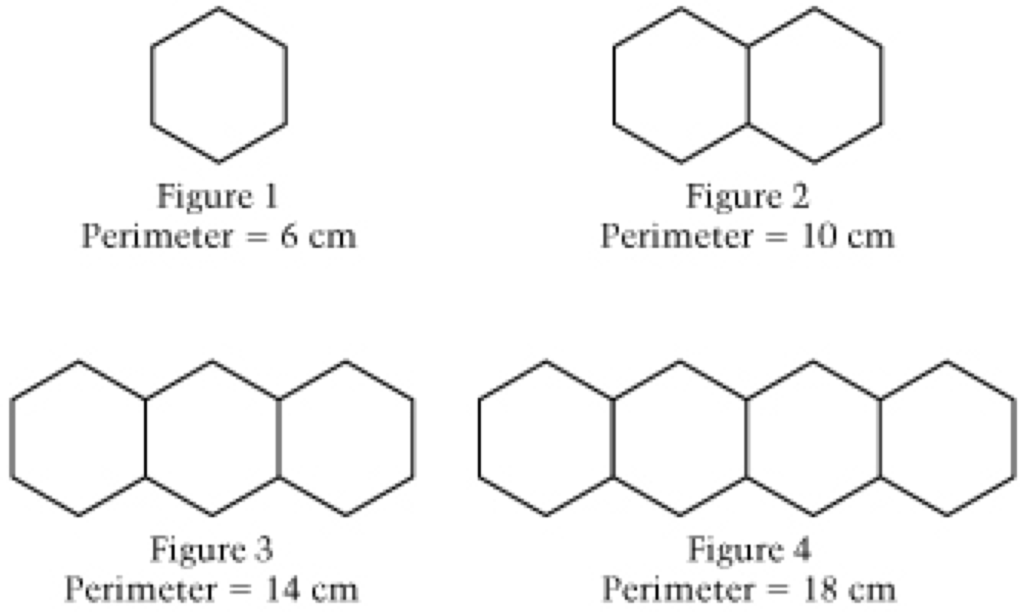

We will start with Private Think Time.

- Draw Figure 5. Find the perimeter of Figure 5.

- If the pattern of adding one hexagon to each figure is continued, what will be the perimeter of the 25th figure in the pattern? Justify your answer.

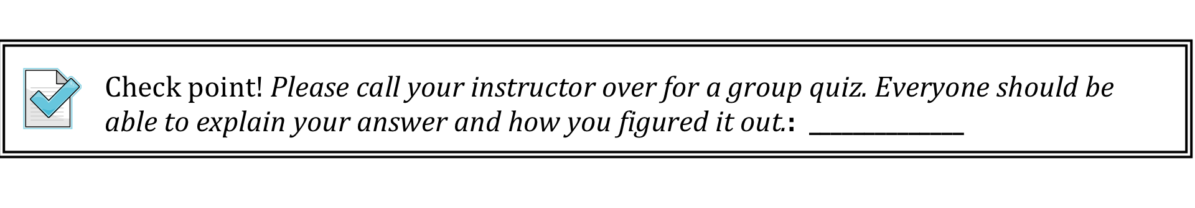
Extension Question:
E1. How can you find the perimeter of any figure? (A figure with n hexagons?)
You may describe this verbally, symbolically, or otherwise.

E2. How many different ways can you write a formula for the nth figure of the hexagon chain? Find as many as you can. Be sure you can link each formula to the diagram!

THINK CARDS

What of figure 100?  What is the perimeter?  How was your process for finding the perimeter of the 100th figure the same as, and different from, finding it for the 25th figure? | Describe what Figure ____ looks like? How many 1cm sides will be on the “top”?  Pick another figure. How many 1cm sides will be on the “top”?
Which sides count towards the perimeter? Which sides do not? | Each hexagon has 6 sides. Do all sides count towards the perimeter?  Do the same sides on each hexagon count towards the perimeter?

