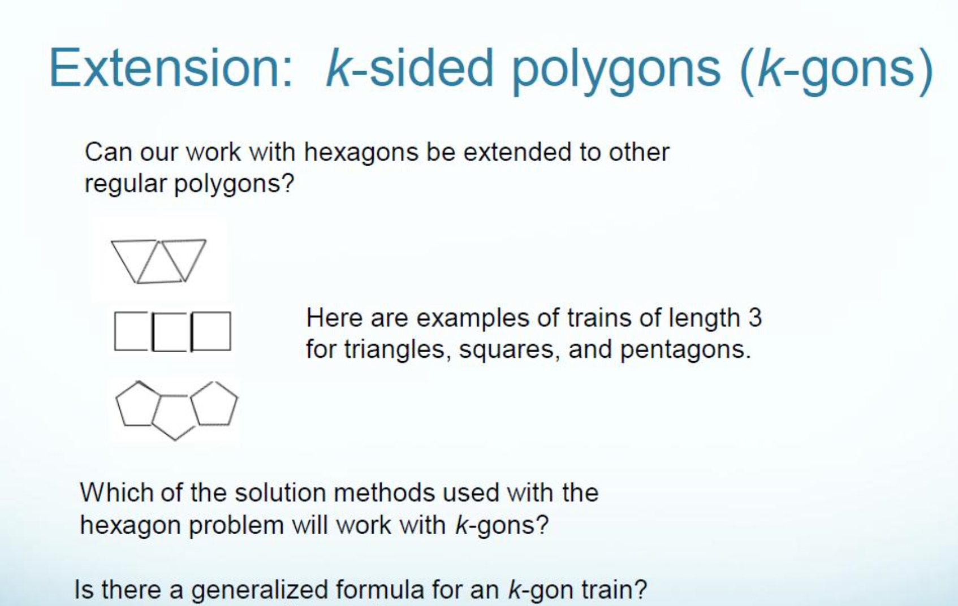

from http://www.nctm.org/profdev/library/default.aspx?id=34507

