Brainstorming and Reflecting
Classroom Routines to Support Mathematical Reasoning

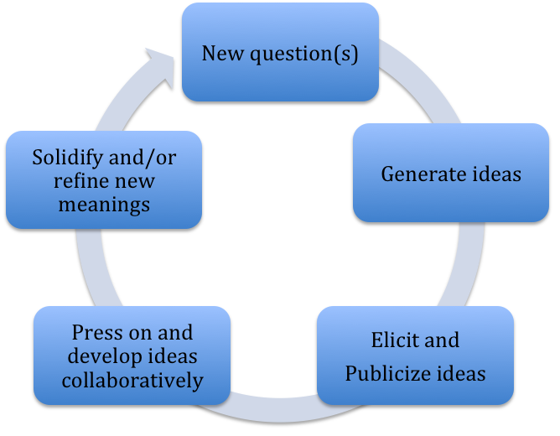
Keeping this model for pedagogical reasoning in mind, brainstorm classroom routines with which you are familiar.

Think about which ones are more likely to be able to be adapted to support this model

Routines More Likely to Support Math Reasoning | Routines Less Likely to Support Math Reasoning (you might want to include what they do accomplish)
- Talk Frame
- Conjectures Routine

Reflection:
Why are some of the routines more likely to support mathematical reasoning than others?

How would you like to use these, or other, routines in your classroom?

What is challenging about making these routines ‘work’ in the classroom? Where do you feel most challenged?

