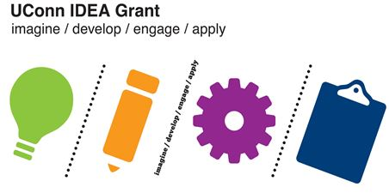
UConn IDEA Grant
Sample Timeline Template

Project Goals and Target Outcomes (What are you hoping to accomplish?):
Target Project End-Date:

Timeline for accomplishing the goals by the target end-date:

Milestones | Dates/Weeks | Breakdown of Tasks
Milestone: Clearly defined measure of accomplishment of a task or sub task | How long do you think it will take to reach this project milestone? What dates or weeks will you focus on this segment of your project? | - Outline the steps you will need to take in the process  - At the end of each step, include the amount of time you anticipate needing for each step
Milestone 1 | 3 weeks – (date – date) | - Step 1 (dates)  - Step 2 (dates)  - Step 3 (dates)  - Step 4 (dates)
Milestone 2

Milestone 3

Milestone 4

UConn IDEA Grant
Sample Timeline Template

Project Goals and Target Outcomes (What are you hoping to accomplish?):

Target Project End-Date:

Timeline for accomplishing the goals by the target end-date:

Goal/Milestone | Breakdown of Tasks (step-by step overview of what you need to do to accomplish each goal) | Date Each Step Should be Completed
Goal/Milestone | - Task 1  - Task 2  - Task 3  - Task 4 | - Week 1  - Week 1 & 2  - Week 2-4  - Week 4
Goal/Milestone | - Task 1  - Task 2  - Task 3 | - Week 3  - Week 3-5  - Week 4-6

UConn IDEA Grant
Sample Timeline Template

Project Goals and Target Outcomes (What are you hoping to accomplish?):

Target Project End-Date:

Timeline for accomplishing the goals by the target end-date

Week/Dates | Activities | Goals/Milestones
Week 1 | - Activity 1  - Activity 2  - Activity 3  - Activity 4 | Goal
Week 2 | - Activity 1  - Activity 2  - Activity 3  - Activity 4 | Goal  Goal
Week 3 | - Activity 1  - Activity 2 | Goal  Goal
Week 4 | - Activity 1  - Activity 2 | Goal  Goal

